Introduction to SimPy using Google Colab

Objective
After completing this lab, students will be able to:
- Understand Discrete Event Simulation (DES).
- Install and import SimPy.
- Create a simulation environment.
- Create and execute processes.
- Simulate events over time.
- Use multiple concurrent processes.
Explore: https://simpy.readthedocs.io/en/latest/index.html

Step 1: Install SimPy

Code Cell
# Install SimPy
!pip install simpy

Step 2: Import SimPy

Code Cell
import simpy
print("SimPy Version:", simpy.__version__)
Expected Output
SimPy Version: 4.x.x

Step 3: First SimPy Program

Theory
A SimPy simulation always starts by creating an Environment. The environment manages the simulation clock and schedules events.

Code Cell
import simpy
env = simpy.Environment()
print("Current Simulation Time:", env.now)
Expected Output
Current Simulation Time: 0

Step 4: Create Your First Process

Theory
A process is a Python function that models the behavior of an entity. It must use yield to pause execution.

Code Cell
import simpy
def clock(env):
while True:
print("Current Time:", env.now)
yield env.timeout(1)
env = simpy.Environment()
env.process(clock(env))
env.run(until=5)
Expected Output
Current Time: 0
Current Time: 1
Current Time: 2
Current Time: 3
Current Time: 4

Step 5: Two Processes Running Together

Theory
SimPy allows multiple processes to execute concurrently.

Code Cell
import simpy
def clock(env, name, interval):
while True:
print(name, "Time =", env.now)
yield env.timeout(interval)
env = simpy.Environment()
env.process(clock(env, "Fast Clock", 1))
env.process(clock(env, "Slow Clock", 2))
env.run(until=6)
Expected Output
Fast Clock Time = 0
Slow Clock Time = 0
Fast Clock Time = 1
Fast Clock Time = 2
Slow Clock Time = 2
Fast Clock Time = 3
Fast Clock Time = 4
Slow Clock Time = 4
Fast Clock Time = 5

Step 6: Customer Arrival Simulation

Theory
This example models a customer arriving and leaving after receiving service.

Code Cell
import simpy
def customer(env, name):
print(name, "arrives at", env.now)
yield env.timeout(3)
print(name, "leaves at", env.now)
env = simpy.Environment()
env.process(customer(env, "Ali"))
env.run()
Expected Output
Ali arrives at 0
Ali leaves at 3

Step 7: Multiple Customers

Code Cell
import simpy
def customer(env, name, arrival):
yield env.timeout(arrival)
print(name, "arrived at", env.now)
yield env.timeout(4)
print(name, "left at", env.now)
env = simpy.Environment()
env.process(customer(env, "Ali", 1))
env.process(customer(env, "Ahmed", 3))
env.process(customer(env, "Sara", 5))
env.run()
Expected Output
Ali arrived at 1
Ahmed arrived at 3
Sara arrived at 5
Ali left at 5
Ahmed left at 7
Sara left at 9

Step 8: Resource Example (One Cashier)

Theory
A Resource represents a limited facility such as a cashier, doctor, or machine.

Code Cell
import simpy
def customer(env, name, cashier):
print(name, "arrives at", env.now)
with cashier.request() as request:
yield request
print(name, "starts service at", env.now)
yield env.timeout(3)
print(name, "leaves at", env.now)
env = simpy.Environment()
cashier = simpy.Resource(env, capacity=1)
env.process(customer(env, "Ali", cashier))
env.process(customer(env, "Ahmed", cashier))
env.run()
Expected Output
Ali arrives at 0
Ahmed arrives at 0
Ali starts service at 0
Ali leaves at 3
Ahmed starts service at 3
Ahmed leaves at 6

Step 9: Resource with Arrival Times

Code Cell
import simpy
def customer(env, name, cashier, arrival):
yield env.timeout(arrival)
print(name, "arrives at", env.now)
with cashier.request() as request:
yield request
print(name, "starts service at", env.now)
yield env.timeout(2)
print(name, "leaves at", env.now)
env = simpy.Environment()
cashier = simpy.Resource(env, capacity=1)
env.process(customer(env, "Ali", cashier, 0))
env.process(customer(env, "Ahmed", cashier, 1))
env.process(customer(env, "Sara", cashier, 2))
env.run()

Step 10: Traffic Light Simulation

Code Cell
import simpy
def traffic_light(env):
while True:
print("Green Light :", env.now)
yield env.timeout(5)
print("Yellow Light:", env.now)
yield env.timeout(2)
print("Red Light :", env.now)
yield env.timeout(5)
env = simpy.Environment()
env.process(traffic_light(env))
env.run(until=20)

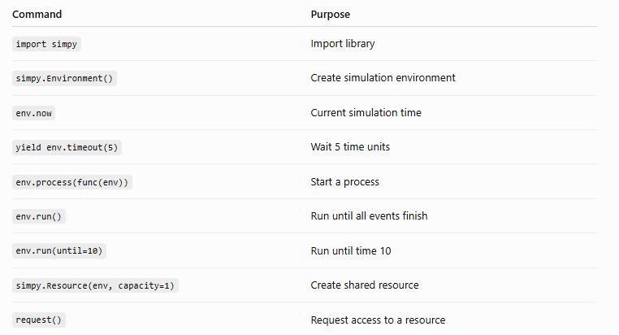

Practice the following exercises in order:
- Hello SimPy – Print the simulation time every second.
- Two Clocks – Run two processes at different time intervals.
- Customer Arrival – Simulate customers arriving and leaving.
- Bank Queue – One cashier serving multiple customers.
- Hospital Queue – Patients waiting for a doctor.
- Manufacturing System – Multiple machines processing jobs.

Exercise 1
Create a clock that prints every 2 time units.

Exercise 2
Create three clocks with intervals of 1, 2, and 3 seconds.

Exercise 3
Simulate five customers arriving at a bank.

Exercise 4
Modify the cashier example to have 2 cashiers instead of 1.

Exercise 5
Create a traffic signal that runs for 30 simulation time units.

Viva Questions
- What is SimPy?
- What is Discrete Event Simulation?
- What is an Environment in SimPy?
- What does env.now return?
- Why is yield used in SimPy?
- What does env.timeout() do?
- What is the purpose of env.process()?
- What is a Resource?
- What happens when multiple processes request the same resource?
- What is the difference between env.run() and env.run(until=10)?

